# LSC Learning Management System

**Project Documentation Submitted**

**To the Faculty of School of**

**Computer Science and Information Technology**

**Of**

**Asia Pacific College**

**In Partial Fulfillment of the Requirements for the subject**

**Applied Projects 2 or Software Development**

**Gardon, Jana Marie G.  
Heramia, Johanna Marisse C.  
Tadeo, Jose Lorenzo G.**

Table of Contents

[LSC Learning Management System 1](#_Toc468481186)

[Executive Summary 5](#_Toc468481187)

[List of Figures, List of Tables, List of Notations 5](#_Toc468481188)

[I. Introduction 5](#_Toc468481189)

[**a.** **Project Context** 5](#_Toc468481190)

[**b.** **Purpose and Description** 5](#_Toc468481191)

[**c.** **Objectives** 6](#_Toc468481192)

[**d.** **Scope and Limitations** 7](#_Toc468481193)

[II. Review of Related Literature/Systems 7](#_Toc468481194)

[III. Technical Background 8](#_Toc468481195)

[IV. Methodology, Results and Discussion 9](#_Toc468481196)

[**a.** **Requirement Analysis** 9](#_Toc468481197)

[**b.** **Requirements Documentation** 9](#_Toc468481198)

[**c.** **Design of Software, Systems, Product, and/or Processes** 11](#_Toc468481199)

[**1.** **Frontend** 11](#_Toc468481200)

[**A.** **Main Page** 11](#_Toc468481201)

[**B.** **Login Page** 11](#_Toc468481202)

[**2.** **Backend** 12](#_Toc468481203)

[**A.** **Login Page** 12](#_Toc468481204)

[**A.** **Main Page** 12](#_Toc468481205)

[**3.** **PhpMyAdmin Database** 13](#_Toc468481206)

[**d.** **Development and Testing, where applicable** 14](#_Toc468481207)

[**e.** **Description of the Prototype, where applicable** 14](#_Toc468481208)

[**f.** **Implementation Plan (Infrastructure/Deployment) where needed** 14](#_Toc468481209)

[**g.** **Implementation Results, where applicable** 14](#_Toc468481210)

[**h.** **Include discussion on conceptual design / system architecture/ block diagrams and algorithms** 14](#_Toc468481211)

[V. Conclusions and Recommendations 14](#_Toc468481212)

[VI. Appendices 15](#_Toc468481213)

[**a.** **Relevant Source Code** 15](#_Toc468481214)

[**b.** **Evaluation Tool or Test Documents** 15](#_Toc468481215)

[**c.** **Sample input/output/Reports** 16](#_Toc468481216)

[**1.** **Event Table – Student** 16](#_Toc468481217)

[**2.** **Event Table – Instructor** 16](#_Toc468481218)

[**3.** **Event Table – Admin** 17](#_Toc468481219)

[**4.** **Use Case Full Description – Student** 17](#_Toc468481220)

[**5.** **Use Case Full Description – Instructor** 20](#_Toc468481221)

[**6.** **Use Case Full Description – Admin** 21](#_Toc468481222)

[**7.** **Use Case Diagram – Student** 22](#_Toc468481223)

[**8.** **Use Case Diagram – Employee** 22](#_Toc468481224)

[**9.** **Activity Diagram – Student** 23](#_Toc468481225)

[**10.** **Activity Diagram – Instructor** 26](#_Toc468481226)

[26](#_Toc468481227)

[**11.**  **Object Diagram** 28](#_Toc468481228)

[**12.** **Class Diagram** 29](#_Toc468481229)

[**13.** **Communication Diagram** 30](#_Toc468481230)

[**14.** **State Machine Diagram – Student** 31](#_Toc468481231)

[**15.** **State Machine Diagram – Employee** 31](#_Toc468481232)

[**16.** **Timing Diagram – Student** 31](#_Toc468481233)

[**17.** **Timing Diagram – Instructor** 31](#_Toc468481234)

[**18.** **Timing Diagram – Admin** 31](#_Toc468481235)

[**19.** **Component Diagram** 31](#_Toc468481236)

[**20.** **Package Diagram** 31](#_Toc468481237)

[**21.** **Deployment Diagram** 31](#_Toc468481238)

[**22.** **Sequence Diagram** 31](#_Toc468481239)

[**23.** **Composite Diagram** 31](#_Toc468481240)

[**24.** **Interaction Diagram** 31](#_Toc468481241)

[**25.** **Context Flow Diagram** 31](#_Toc468481242)

[**26.** **Data Flow Diagram – Level 0** 31](#_Toc468481243)

[**27.** **Data Flow Diagram – Level 1 – Create Requirement** 31](#_Toc468481244)

[**28.** **Data Flow Diagram – Level 1 – Update Student Grade** 31](#_Toc468481245)

[**29.** **Data Flow Diagram – Level 1 – Update Student Profile** 31](#_Toc468481246)

[**30.** **Entity Relationship Diagram** 31](#_Toc468481247)

[**31.** **Data Dictionary** 31](#_Toc468481248)

[**32.** **Gantt Chart** 31](#_Toc468481249)

[**33.** **WBS** 31](#_Toc468481250)

[**34.** **Activity List** 31](#_Toc468481251)

[**35.** **Project Vision and Scope** 31](#_Toc468481252)

[**36.** **Statement of Work** 31](#_Toc468481253)

[**37.** **Software Requirement Specification** 31](#_Toc468481254)

[**38.** **Change Management Plan** 31](#_Toc468481255)

[**39.** **Quality Plan** 31](#_Toc468481256)

[**d.** **Users Guide** 32](#_Toc468481257)

[**e.** **Process/Data/Information Flow** 32](#_Toc468481258)

[**f.** **Screen Layouts** 32](#_Toc468481259)

[**g.** **Test Results** 32](#_Toc468481260)

[**h.** **Sample Generated Outputs** 32](#_Toc468481261)

[**i.** **Pictures showcasing the data gathering, investigation done** 32](#_Toc468481262)

[**j.** **One-Page Curriculum** 33](#_Toc468481263)

# Executive Summary

The Loyola Student Center (LSC) Learning Management System is for the students and for the management of Loyola Student Center. This system will be able help the student to track or analyze their performance based on the results of their completed tasks. Through the student’s analyzation, they will be able to know whether they need more improvement on their performance in class. Also, student can be notified easily if there are announcement(s) from their respective tutors in their classed. In the management side, system could help them through management of the student's courses, tasks and attendance. Under a course that is created by the tutor, there are specific tasks that they can create, update or delete.

# List of Figures, List of Tables, List of Notations

# Introduction

## **Project Context**

## **Purpose and Description**

The following are the Loyola Student Center's current system:

* The schedule is given by the instructor manually and the student will write it on the paper.
* The student's summary of grades can't be seen by the student unless he/she asks or the test's result is given by a professor.
* The activity of the student such as assignments or quizzes are paper based.

The Loyola Student Center current system's difficulty will be improvised by having LSC Learning Management System. It helps the student and administrator or tutor to have easier administration, faster administration of student's records online, taking activity, efficient way of gathering reports and summarization of student's performance. The following are the propose system's improvement:

* The student can view schedule online.
* The student can view summary of grades together with the attendance.
* The student can take exercise, homework or quiz online.
* The student can easily update information if there are any changes.
* The student’s instructor can easily view student's attendance, can view summary of grades, can update or add exercises, homework and quizzes.

Building this system will benefit the following:

**To the Students**

Students of Loyola Student Center (LSC) can benefit the system in many ways. Students can use the system anywhere and they only need an internet connection to allow them to connect to the system. Student can check their schedule whether a change has been made or not. Students can check if they missed a class or not. Students can take and pass their homework without using a paper and student can view his or her performance in the class through the system by viewing his or her grades.

**To the Parents**

Learning Management System utilizes webs application for teaching much information in a convenient way for parents as well. Using LMS allows parents to review the course curriculum, classroom calendar and monitor their student's progress. It simultaneously keeping parents in tune with what is going on by informing them through email or through message.

**To the Administrators**

Administrating a tutorial center manually is not easy if they have numerous of students enrolled. Recording grades, recording attendance, giving away quizzes, exercises and homework through paper is one of the vital part of the existing system that needs to be address. That is the reason why administrator can benefit from this system because: first, they can give assignments, homework or quizzes online right away. Secondly, they can easily manage student's attendance and grades in every class.

## **Objectives**

**General Objectives**

* To provide student an efficient way of learning by using the Learning Management System.
* To give the student a faster tracking of their performance to know what is needed to improve.
* To provide easier administration of every class.

**Specific Objectives**

* To provide the Loyola Student center with a system for the learning management system and a database for their requirements.
* For faster administration of records of the task, grades and attendance of students in classes.
* For the administrator to announce updates faster and those announcements can see right away by the students in each class.
* For the students of Loyola Student Center to have easier access on their progress online.

## **Scope and Limitations**

The coverage of LSC Learning Management System are:

* Instructor can create and update course in classes.
* Instructor can add tasks such as quiz, exam or exercise in classes.
* Instructor can add announcements on calendar.
* Student can view their grades and attendance.

The LSC Learning Management system is only limited for the students of Loyola Student Center. This system will not cover the enrolment of the student; therefore, it is assumed that the student is already enrolled. Students who are enrolled will automatically have an account.

# Review of Related Literature/Systems

**Moodle** is the most popular open-source learning management system (LMS) in the world. They've implemented Moodle LMS in hundreds of businesses, schools, colleges and training organizations around the world. They provide the full range of Moodle services, from theme design and consultation, to installation, training and technical support. Documentation, trackers and resources are all provided through Moodle. The site does not have a specific "K-12" product, however, if a teacher or administrator is tech-savvy enough, they can bend the program to their school or district's needs. The following are the functions of Moodle:

* Organize and display courses the way user want, and view at a glance current tasks and messages.
* Moodle’s calendar tool helps keep track of academic or company calendar, course deadlines, group meetings, and other personal events.
* Format text and conveniently add media and images with an editor that works across all web browsers and devices.
* When enabled, users can receive automatic alerts on new assignments and deadlines, forum posts and also send private messages to one another.
* Educators and learners can track progress and completion with an array of options for tracking individual activities or resources and at the level of course.

**Learnanywhere** is an LMS which we've created specifically for elementary schools. The interface is designed to be simple to use and easy for young students to get to grips with. It includes a reward system to help encourage younger learners to succeed in their work. The system is hosted in the cloud, allowing students and teachers access from home or school. Learnanywhere makes the process of creating courses, activities and quizzes easy for teachers, saving valuable time, and helps to engage parents in their children's learning. These are the functions of Learnanywhere:

* Add multimedia content, and celebrate achievement with on-screen rewards and customizable learning buddies.
* Keep parents up to date on their child's progress with MIS integration, parent forums and online newsletters.
* Set self-marking quizzes to cut down on marking, and store resources online for easy access.
* Assign personalized study aids and extension activities. Tailor resources according to ability.

# Technical Background

The system was built using Yii2 framework in both Frontend and Backend. Yii is an open source, object-oriented, component-based MVC PHP web application framework. Models and CRUD were generated. To connect to data, Apache Web Server and XAMPP Control Panel was used. All the data gathered are stored in a database powered by MySQL.

# Methodology, Results and Discussion

Once the student was already enrolled in LSC, he/she will automatically have a LSC-LMS account. The student must log-in first to be able to view his/her schedule and if there are announcement student will be able to notify if there is an upcoming event through the LMS calendar automatically. The attendance of the student can also be viewed. The student can take quiz, assignment or exercises. All the scores that was recorded can be checked. The profile information of the student is also included in the system and can still be able to update by the student.

## **Requirement Analysis**

After meeting with the client, we come up with the idea of having a learning management system since their current system is still paper-based process. The reason why they are still using papers when giving quizzes, exercises and homework is because they are concerned with the security of their materials. They do not want their materials to be printed or to be print screened. So, the LSC Learning Management System must be very well secured not just with the materials, but also with the students and administration accounts. Everything must be secured and must be efficient to the user of the system.

## **Requirements Documentation**

After meeting with the client and discussed about the project, we came up with list of requirements:

* The enrolled student must have a LSC-LMS account.
* On the frontend side, the student can view his/her attendance and schedule.
* The student can update his/her profile.
* The student can view the upcoming events or task in the calendar.
* The student can take quizzes, assignments or exercises.
* The student can view his/her score from the tasks.
* On the backend side, admin can create courses and subjects underneath.
* The admin can update quiz, assignments or exercises.
* The admin can monitor the student's attendance.

## **Design of Software, Systems, Product, and/or Processes**

## **Frontend**

## **Main Page**

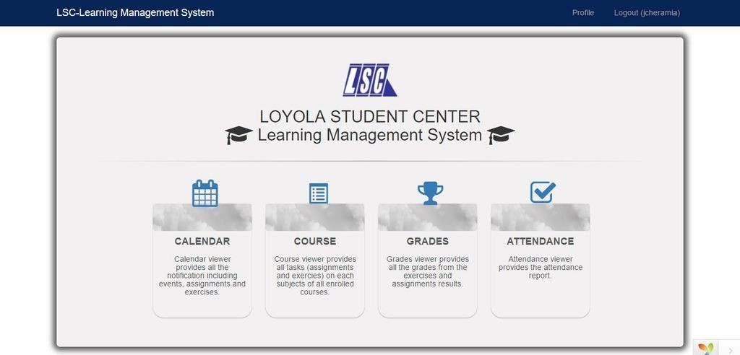

## **Login Page**

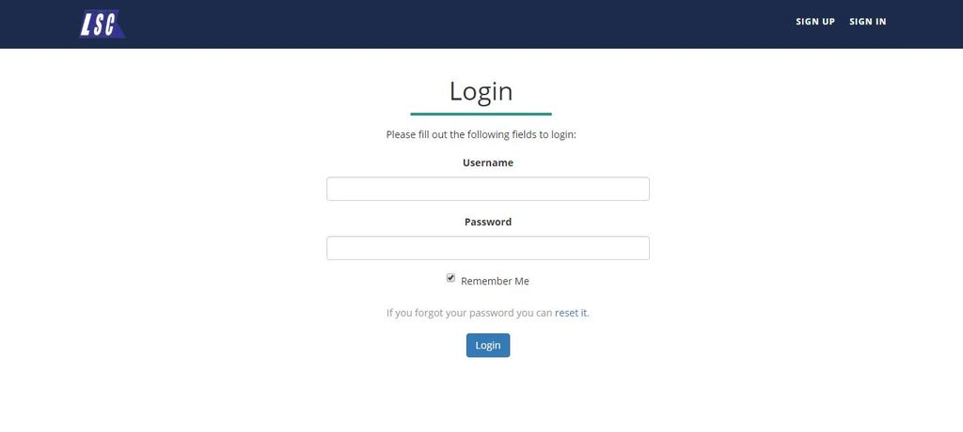

## **Backend**

## **Login Page**

**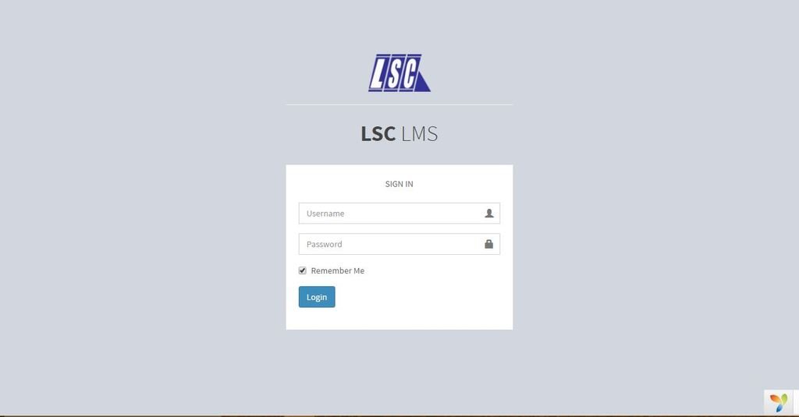**

## **Main Page**

**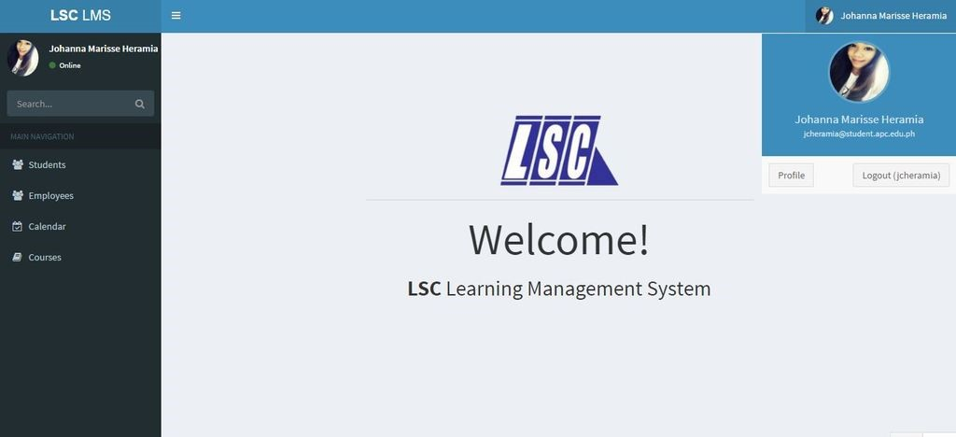**

## **PhpMyAdmin Database**

**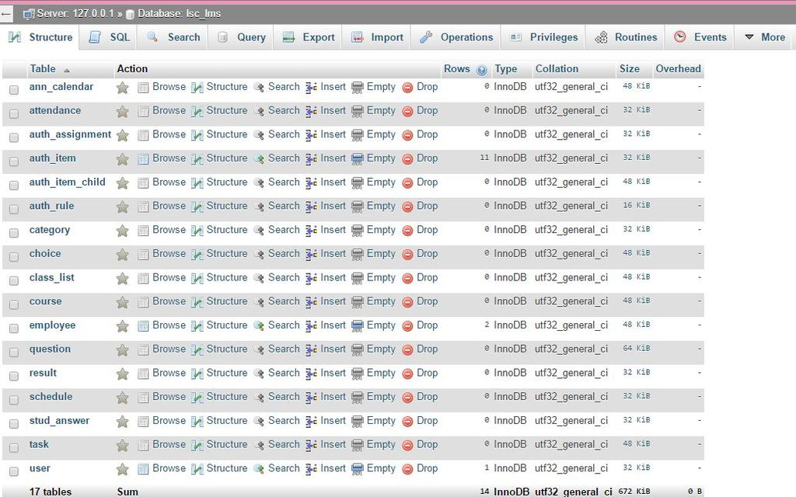**

## **Development and Testing, where applicable**

## **Description of the Prototype, where applicable**

## **Implementation Plan (Infrastructure/Deployment) where needed**

## **Implementation Results, where applicable**

## **Include discussion on conceptual design / system architecture/ block diagrams and algorithms**

# Conclusions and Recommendations

As a conclusion, we were able to analyze the processes of the system and we were able to create the working prototype for the student(frontend) and (backend). We also generated forms and models that can be view and update by the user. Features and designs are not yet completed and the team will work faster to be able to reach the scope of the system.

For the recommendation of creating a system, first, always plan and distribute the things that the team are going to do. Second, select a schedule for deadline and present it to the client many times before having a final presentation of the system for the changes needed. Third, since this system is not the only project that needs attention, manage time properly and always make a schedule so that everything would be fine. Lastly, do not start working on the project the week after the presentation.

# Appendices

## **Relevant Source Code**

## **Evaluation Tool or Test Documents**

## **Sample input/output/Reports**

## e.t%20studentproposed_zpsmtyoawld.png**Event Table – Student**

## 

## 

## **Event Table – Instructor**

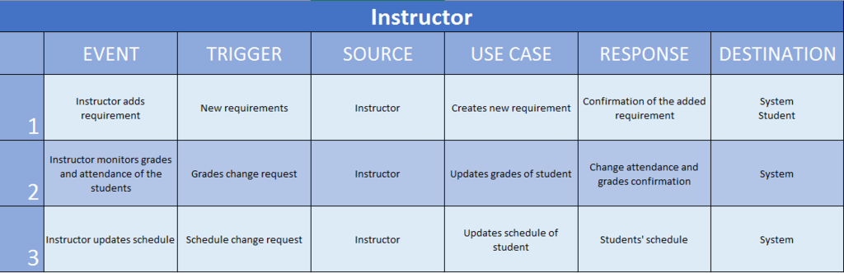

## Event_Table_Propose_Admin_zpstqqjodl7.png**Event Table – Admin**

## Use%20Case%20FD%20Stud%201_zpssugsw0zk.png**Use Case Full Description – Student**

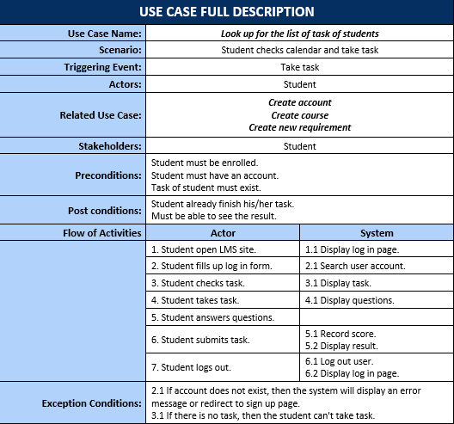

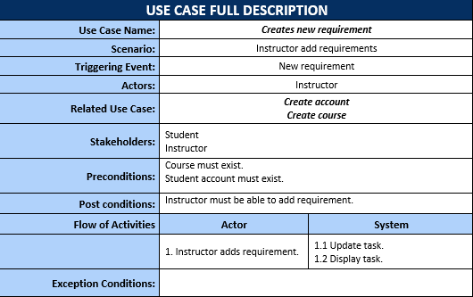

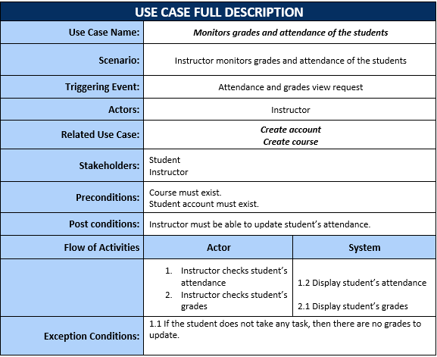

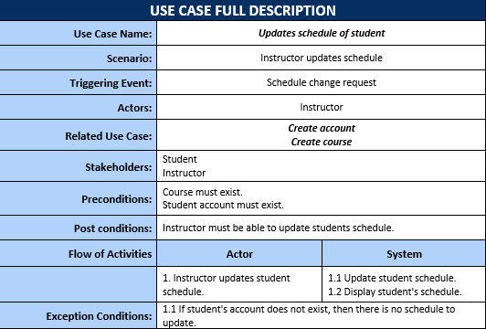

## Use%20Case%20FD%20Admin%201_zpsa2chaxyw.png**Use Case Full Description – Instructor**

## **Use Case Full Description – Admin**

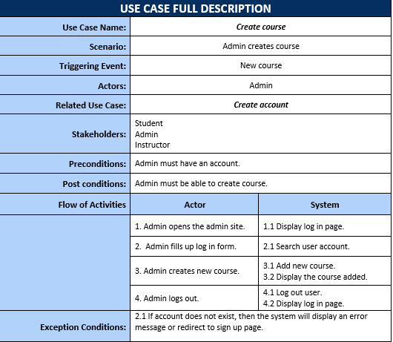

## UseCase-Diagram-Student_zpsqmhp9tc8.png**Use Case Diagram – Student**

## UseCase-Diagram-Employee_zpspgfztrux.png**Use Case Diagram – Employee**

## Activity%20Diagram%20-%20Student%201_zpsg1qu3dg4.png**Activity Diagram – Student**

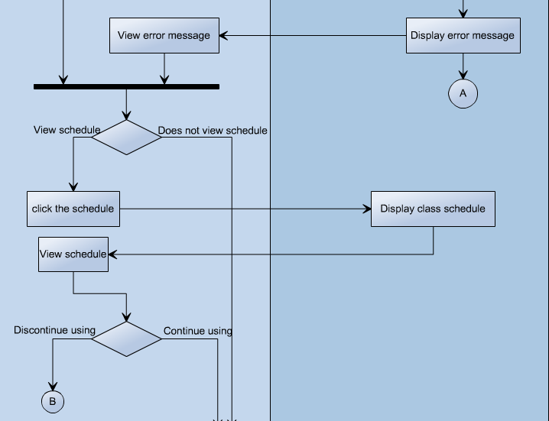

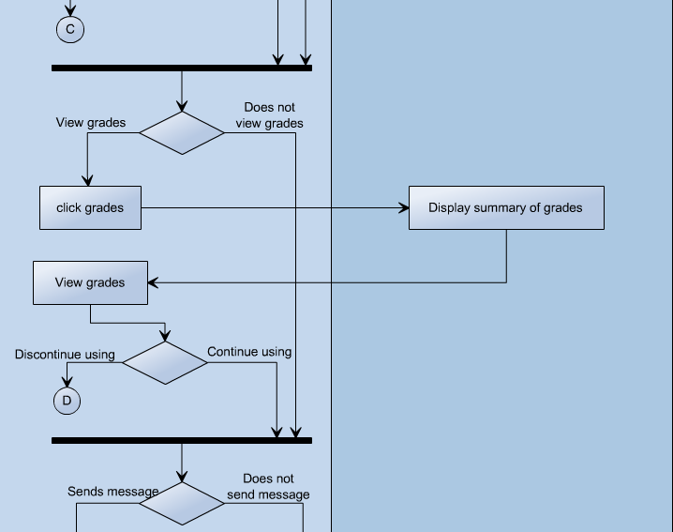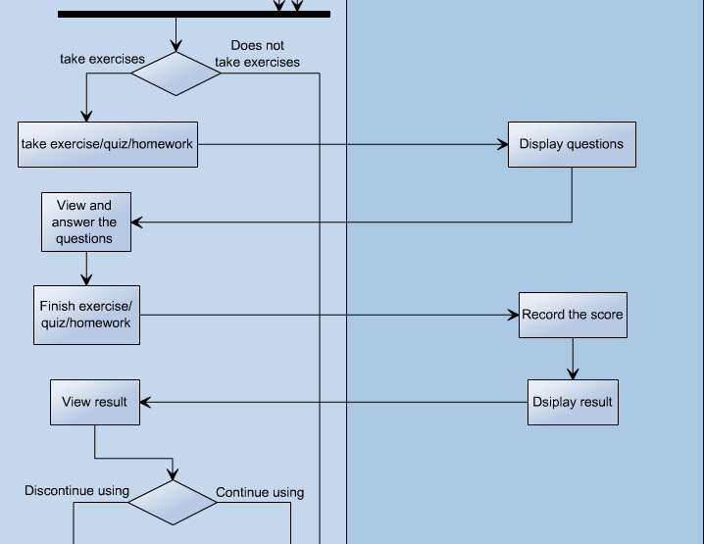

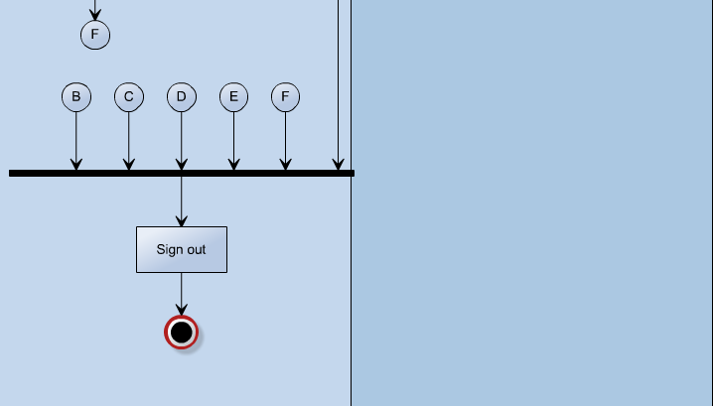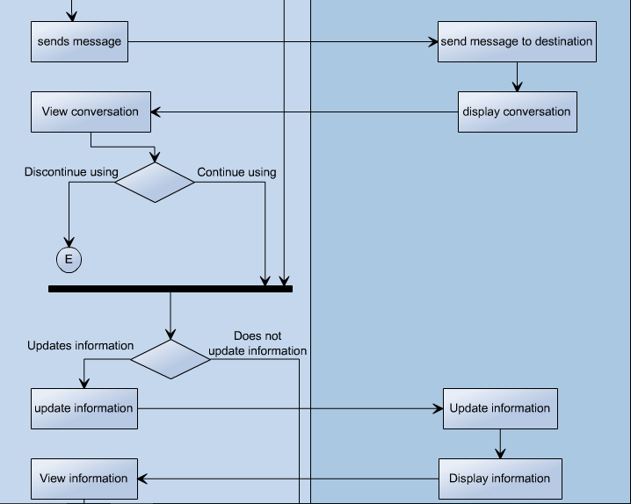

## **Activity Diagram – Instructor**

## Activity%20Diagram%20Instructor%201_zpszz6du5ca.png

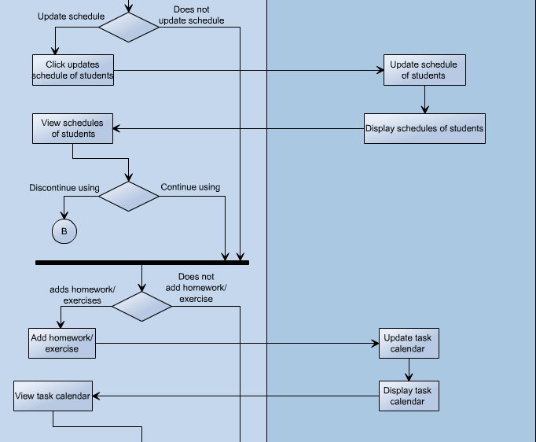

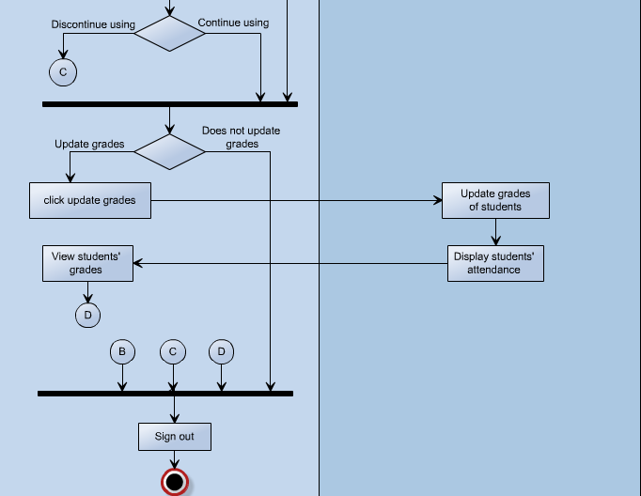

## objectdiagram_zpsfesaxaph.png **Object Diagram**

## **Class Diagram**

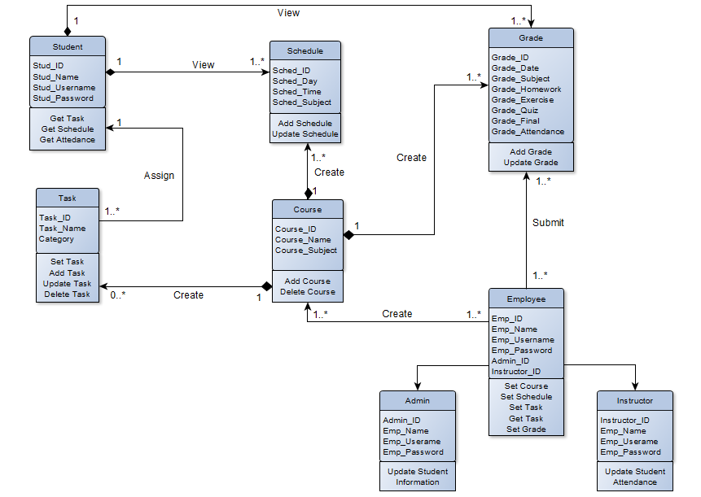

## **Communication Diagram**

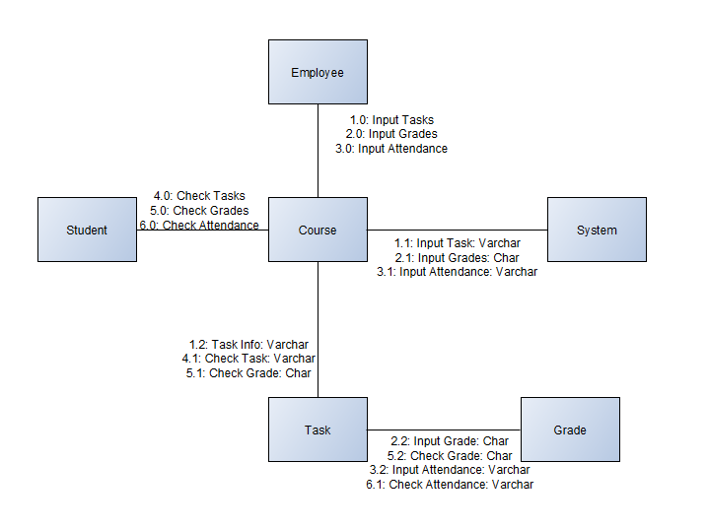

## **State Machine Diagram – Student**

## **State Machine Diagram – Employee**

## **Timing Diagram – Student**

## **Timing Diagram – Instructor**

## **Timing Diagram – Admin**

## **Component Diagram**

## Package_zpsddydugjx.png**Package Diagram**

## 

## **Deployment Diagram**

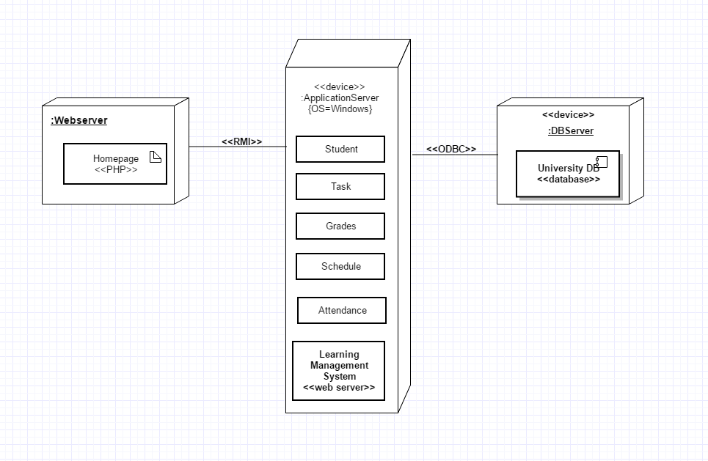

## **Sequence Diagram**

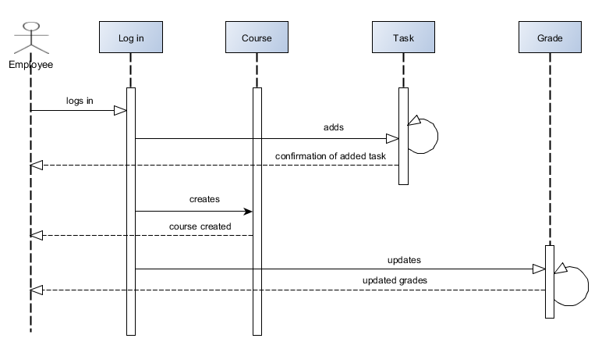  
  
  
  
  
  
  
  
  
  
  
  
  
  
  
  
  
  
  
  
  
  
  
  
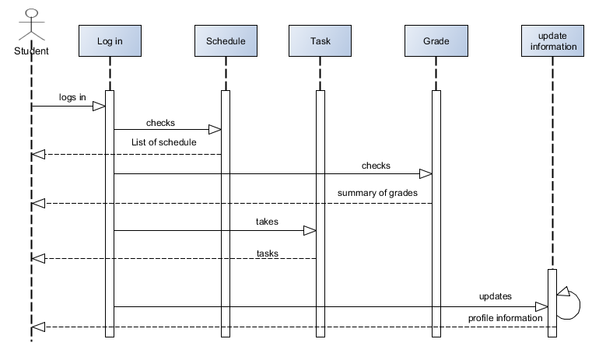

## **Composite Diagram**

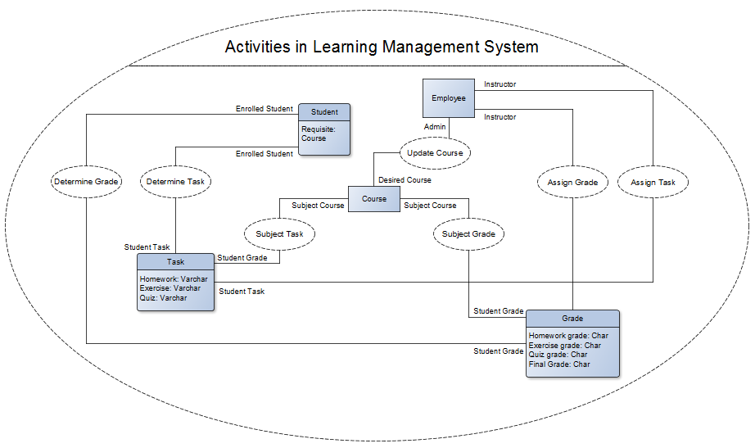

## InteractionOverviewDiagram_zpsz7rkvsqh.png**Interaction Diagram**

## **Context Flow Diagram**

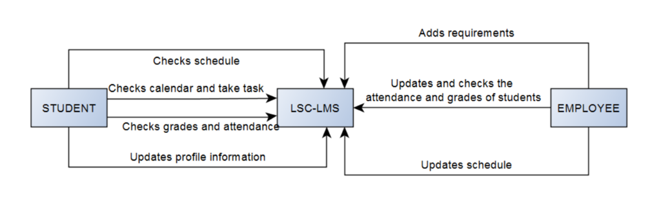

## **Data Flow Diagram – Level 0**

## **Data Flow Diagram – Level 1 – Create Requirement**

## **Data Flow Diagram – Level 1 – Update Student Grade**

## **Data Flow Diagram – Level 1 – Update Student Profile**

## **Entity Relationship Diagram**

## **Data Dictionary**

## **Gantt Chart**

## **WBS**

## **Activity List**

## **Project Vision and Scope**

## **Statement of Work**

## **Software Requirement Specification**

## **Change Management Plan**

## **Quality Plan**

## **Users Guide**

## **Process/Data/Information Flow**

## **Screen Layouts**

## **Test Results**

## **Sample Generated Outputs**

## **Pictures showcasing the data gathering, investigation done**

## **One-Page Curriculum**